Team Name: TeamName

1. Problem overview:

In Taiwan, the medical resources inequality has already bothered people live in the remote area for quite a long time. Even if they have the chance to search for medical treatment in a big city, a lot of the families in remote area can only afford the surgery fee and the hospital expenses for one person, which is the patient. They can’t afford the rental or hotel expenses before the surgery because they might have to arrived a few days earlier. And maybe they can’t accompany the patient during the treatment, which is a very important part to show support for the patient. So our main goal of this project is to provide a solution to resolve this medical visit problem.

1. Architecture Diagram/ Project overview:

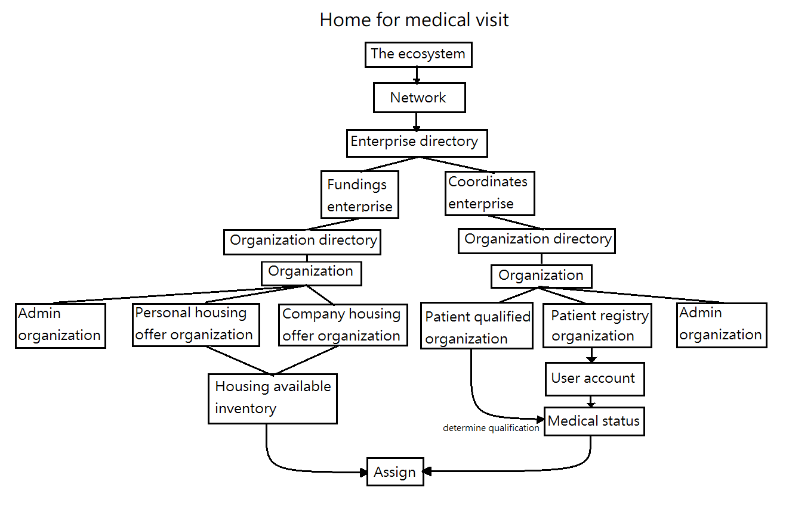

In this project, there will be a Funding enterprise, which provide the necessary fund for the project. There will also be a Coordinate enterprise, which basically take care of most of the pairing issue and qualification part.

Now, let’s take a look at Organizations of Funding enterprise. Personal housing offer allows kind people who has some extra rooms, can apply to offer their room for the patient and family in need. Of course there will be a qualification process to assure the kind people is capable to offer their rooms.

The company housing offer, means the rooms offered by the funding enterprise.

For the Coordinate enterprise part, they’re responsible to check if the patient or family register for the room is qualified by checking their medical status and financial status. When there’s an empty house/ room available, and the patient/ family is qualified for the service, they can live in the house offered by funding enterprise/ people during the process of medical treatment (for their family member or the patient himself). And it’s FREE.

People might ask why would an enterprise offer this kind of service with no charge? We believe this is a good way to improve the reputation of the company and a great chance to give back to the society. They can even use this project as their commercial slogan. Something like “buy one phone, and will provide more funding for the family in need”. So I think it’s a good way to give back to the society and at the same time create a great commercial effect.

1. Application Key Functionalities:

Patient who needs this service can register for the housing service, and provide their basic personal status( medical, financial, address, number of person will come, etc.). Then the coordinate can check if the patient is qualified. If so, the system will match the best house available in the moment and provide it for the family for free.

We can create enterprises and set up room details (offered by the enterprise themselves and the kind people). After that, coordinate enterprise admin can create patient status after their qualified. When a patient create a request, the system will automatically match the best room for the patient.